Chapter 16, Problem 28.

For the circuit in Fig. 16.51, find v(t) for t > 0.

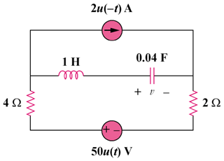
4u(–t) A
100u(t) V

Figure 16.51
For Prob. 16.28.

